**ATAR Physics Year 11**

**Semester One Examination, 2016**

**Question/Answer Booklet**

Student Name: ___________________________________

**Time allowed for this paper**

Reading time before commencing work: 10 minutes

Working time for paper: 3 hours

**Materials required/recommended for this paper**

***To be provided by the supervisor***

This Question/Answer Booklet and the Formulae and Constants Sheet

***To be provided by the candidate***

Standard items: pens (blue/black preferred), pencils (including coloured), sharpener, correction tape/fluid, eraser, ruler, highlighters

Special items: non-programmable calculators approved for use in the WACE examinations, drawing templates, drawing compass and a protractor

**Important note to candidates**

No other items may be taken into the examination room. It is your responsibility to ensure that you do not have any unauthorised notes or other items of a non-personal nature in the examination room. If you have any unauthorised material with you, hand it to the supervisor before reading any further.

**Structure of this paper**

|  |  |  |  |  |  |
| --- | --- | --- | --- | --- | --- |
| **Section** | Number of questions available | Number of questions to be answered | Suggested working time (minutes) | Marks available | **Marks Attained** |
| Section One: Short answers | 13 | 13 | 54 | 54 (30%) | /54 |
| Section Two: Problem-solving | 7 | 7 | 90 | 90 (50%) | /90 |
| Section Three: Comprehension | 2 | 2 | 36 | 36 (20%) | /36 |
|  |  |  |  | 180 (100%) | /180 |

**Instructions to candidates**

Write your answers in the spaces provided beneath each question. The value of each question (out of 150) is shown following each question.

The enclosed Physics: Formulae and Constants Sheet may be removed from the booklet and used as required.

Calculators satisfying conditions set by the Curriculum Council may be used to evaluate numerical answers.

Answers to questions involving calculations should be evaluated and given in decimal form.

Give final answers to three significant figures and include appropriate units where applicable.

When calculating numerical answers, show your working or reasoning clearly. Despite an incorrect final answer, credit may be obtained for method and working, providing this is clearly and legibly set out.

Questions containing specific instructions to **show working** should be answered with a complete, logical, clear sequence of reasoning showing how the final answer was arrived at; correct answers which do not show working will not be awarded full marks.

Questions containing the instruction **estimate** may give insufficient numerical data for their solution. Students should provide appropriate figures to enable an approximate solution to be obtained. When estimating numerical answers, show your working or reasoning clearly. Give final answers to a maximum of two significant figures and include appropriate units where applicable.

**Section One: Short answers (54 Marks)**

This section has **thirteen (13)** questions. Answer **all** questions. Write your answers in the spaces provided.

Suggested working time: 54 minutes.

Question 1 (3 marks)

Convert each of the following values as indicated:

3.0 μC = nC

255 K = °C

4.0015 amu = kg

Question 2 (5 marks)

A cup of coffee is hotter than a warm bath, but the bath water can transfer more heat to its surroundings than the cup of coffee.

(a) At the molecular level, what does it mean when we say that the “cup of coffee is hotter than a warm bath”? (2 marks)

(b) Explain how the bath water can transfer more heat to its surroundings than the cup of coffee, even though it is at a lower temperature. (3 marks)

**Question 3 (4 marks)**

Two charged balls, one positive and the other negative, are placed near one another as shown in the diagram below. Sketch the electric field in the region around the two charges AND draw arrows at points X and Y to show the electric force on a small positive charge placed at each of those points.

X

Y

Question 4 (4 marks)

A promising reaction that produces energy by nuclear fusion occurs between the nuclei of the two heavy isotopes of hydrogen - deuterium (D) and tritium (T). Calculate the amount of energy released during this reaction, which is shown below, given the following values of mass.

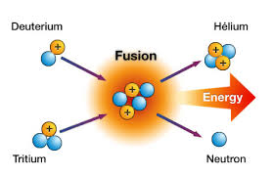m (deuterium) = 3.34354 x 10-27kg

m (tritium) = 5.00742 x 10-27kg

m (helium-4) = 6.64473 x 10-27kg

m (neutron) = 1.67496 x 10-27kg

Question 5 (5 marks)

The resistance of a toaster increases as the heating element becomes hotter.

(a) Describe how the current through the heating element changes as the element heats up and briefly explain why this happens. (3 marks)

(b) How large is the resistance of the heating element if a current of 5.00 A flows at the operating voltage of 240 V? (2 marks)

Question 6 (4 marks)

Compare the nature and charge of the three naturally occurring forms of nuclear radiation by filling in the missing cells in the table below.

|  |  |  |
| --- | --- | --- |
| Radiation | Nature – what is it? | Charge |
| α |  |  |
| β |  | -1 |
| γ | high frequency electromagnetic radiation |  |

Question 7 (4 marks)

Explain the following observations, using appropriate physics terminology.

(a)It feels colder standing barefoot on cement than on a mat in the same room. (2 marks)

(b) People suffering from hypothermia (extreme cold) are wrapped in shiny silvery blankets. (2 marks)

Question 8 (4 marks)

Three 12 Ω resistors can be connected together in four different ways to give four different effective resistance values. **Sketch** the four different ways that the resistors can be arranged and **state** the effective resistance for each case.

Question 9 (4 marks)



A 12.0 V car battery is used to start the engine of a car, which, being cold and out of tune, only starts after 30 seconds of trying.

(a)If the starter motor draws an average current of 120 A during this time, calculate the total charge drawn from the battery in getting the engine to start. (2 marks)

(b) Calculate the total energy supplied by the battery during this time. (2 marks)

Question 10 (4 marks)

Heat may be transferred by several mechanisms. A well-designed house should minimise heat transfer between the interior and the surroundings. State which of the mechanisms of heat transfer each of the following features has been designed to reduce.

Weather seals on doors

Bulk insulation in the roof cavity

Eaves above windows

Pelmets above curtains

Question 11 (5 marks)

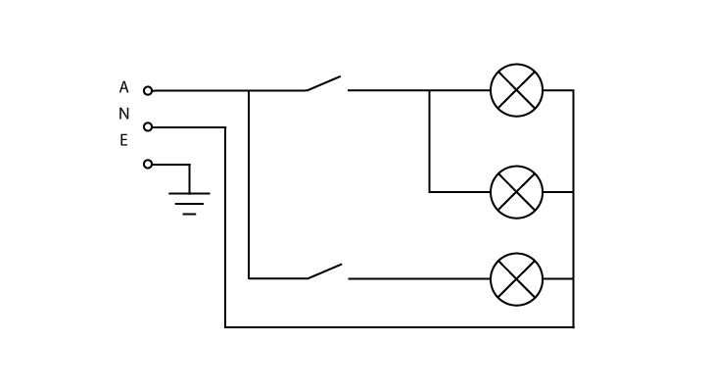The diagram at right shows a domestic (240 V) lighting circuit that operates three 12 W light bulbs using two switches.

(a) Will more current flow when the top switch or the bottom switch is closed? Briefly explain your answer. (3 marks)

(b) Calculate the total current drawn when both switches are closed so that all the light bulbs are in operation. (2 marks)

Question 12 (4 marks)

A 75 kg worker in a nuclear power plant receives 0.30 J of energy from radiation in one year.

(a) What is their absorbed dose in milligray (mGy)? (2 marks)

(b) Given that 50% of the absorbed dose was from fast neutrons and the other 50% was from gamma radiation, find their dose equivalent (in mSv). (2 marks)

Question 13 (4 marks)

The diagram below shows how refrigerant fluid is cycled around a typical car air-conditioning system.

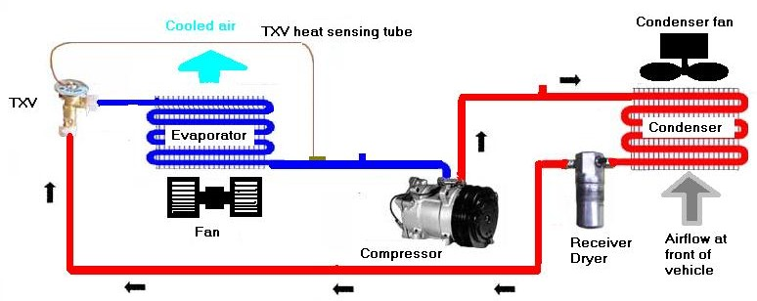

(a) Indicate the change in phase and the change in temperature of the refrigerant fluid after passing through the TXV (expansion valve) by circling your choice from the options below.

Phase change: condensation evaporation liquefaction (1 mark)

Temperature: stays same increases decreases (1 mark)

(b) Explain the following features of the evaporator and condenser coils, as shown above

(i) each coil is contained within a metal grid (1 mark)

(ii) each coil has a fan helping move air over the coil (1 mark)

**END OF SECTION ONE**

**Section Two: Problem Solving (90 Marks)**

This section has **seven (7)** questions. Answer **all** questions. Write your answers in the spaces provided.

Suggested working time: 90 minutes.

Question 14 (14 marks)

A 12.0 volt battery is connected to a circuit as shown in the diagram below. The current flowing from the battery is 1.50 A while the current through resistor R1 is 0.60 A.

12.0 V

R2

6.0 Ω

R1

4.0 Ω

### X

### Y

### 1.50 A

0.60 A

(a) State the current through the

(i) 4.0  resistor (1 mark)

(ii) 6.0  resistor (1 mark)

(b) Calculate the potential difference (voltage) between points X and Y. (2 marks)

(c) Find the rate at which heat is produced in the 6.0 Ω resistor. (2 marks)

(d) Find the value of resistor R1 (3 marks)

(e) Find the value of resistor R2 (2 marks)

(f) The resistors R1 and R2 are replaced with known values of 8.0 Ω  and 15.0 Ω respectively. What is the effective resistance of the whole circuit now? (3 marks)

Question 15 (11 marks)

The radioactive isotope carbon-14 is produced in the upper atmosphere when energetic neutrons from cosmic radiation collide with atoms of atmospheric nitrogen. The carbon-14 eventually undergoes beta decay back to nitrogen-14, over a time scale measured in thousands of years, as shown in the graph below. During this time the carbon-14 is absorbed by plants during photosynthesis and makes its way through the food chain, ultimately being absorbed by all living organisms.

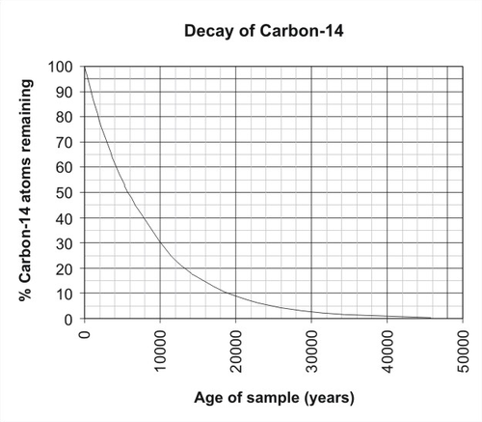

(a) Write balanced nuclear equations for

(i) the production of carbon-14 in the upper atmosphere (note: another particle is produced as a by-product each time a C-14 atom is formed) (2 marks)

(ii) the  decay of carbon-14 back to nitrogen (1 mark)

(b) Estimate the half-life of carbon-14, showing relevant working on the graph. (2 marks)

(c) Carbon-14 dating is only effective up to a maximum age about 50,000 years. Using your value of half-life estimated above, calculate the percentage of carbon-14 atoms remaining after 50,000 years. (3 marks)

(d) Explain how the presence of the radioactive isotope carbon-14 can be used to date ancient human remains (such as bones). (3 marks)

Question 16 (15 marks)

The graph below shows the heating curve for a sample of water that was heated in a sealed container from an initial state as very cold ice until all the water had been converted into steam. The various stages of the heating curve have been labeled with the letters a, b, c, d and e.

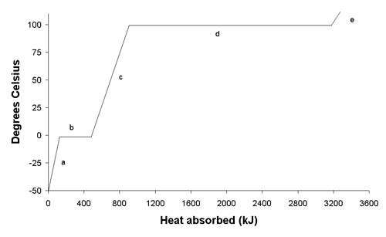

(a) Describe, in terms of the kinetic theory, what is happening to the water molecules as the sample of water absorbs heat during stage c. (2 marks)

(b) During stages b and d the water is being continually heated yet the temperature does not increase. Briefly explain what is happening during these two stages. (2 marks)

(c) Explain why the amount of heat absorbed during stage d is much larger than that absorbed during stage b. (2 marks)

(d) Explain why the gradient of the graph is steeper during stage a than stage c. (2 marks)

(e) From the graph estimate the quantity of heat absorbed during stage d and hence the mass of the water in the sealed container. (3 marks)

(f) An evaporative air conditioner cools every cubic metre of air passing through it by evaporating 3.5 g of water from its filter. Given that the density of air is 1.275 kg per m3 and that air has a specific heat capacity of 1005 Jkg-1K-1, calculate the temperature drop experienced by every cubic metre of air passing through the air conditioner. (4 marks)

Question 17 (11 marks)

switch

load

neutral

earth

active

The diagram at right shows the

typical way that an appliance

is connected to household wiring.

All appliances and lights within

a household are connected in

parallel to each other.

Electrical power is supplied

at 240 V via the meter box.

(a) What are **two** advantages of connecting household appliances in parallel, rather than in series? (2 marks)

(b) Briefly explain the difference between the active wire and the neutral wire in a household circuit. (2 marks)

(c) Why is a switch always placed on the **active** wire leading to an appliance, rather than on the **neutral** wire, given either position enables current flow to be stopped? (2 marks)

(d) A domestic appliance is designed to produce 1200 W of power. What is its resistance when in operation? (2 marks)

(e) Explain the function of the earth wire that is connected to the metallic casing of an appliance. (3 marks)

Question 18 (11 Marks)

The apparatus shown at right can be used to investigate the specific heat capacity of a liquid.

415 grams of an unknown liquid is carefully weighed out and poured into the beaker. An electric current is then passed through the heating element in the beaker for a period of 10.0 minutes.

During this time the voltmeter measures the potential difference across the heating element to be 11.2 V and the ammeter measures the current through the heating element to be 3.45 A.

A thermometer placed in the beaker shows that the temperature of the liquid increases from 21.5°C to 36.0°C during this time.

(a) Calculate the amount of heat energy produced by the heating element during the 10.0 minute period of heating. (3 marks)

(b) Determine a value for the specific heat capacity of the unknown liquid. (3 marks)

(c) Would you expect theactual value for the specific heat capacity of the unknown liquid to be larger or smaller than the value calculated above? Explain your answer. (3 marks)

(d) What practical modifications could be made to this experiment in order to get a more accurate value for the specific heat capacity of the unknown liquid? (2 marks)

Question 19 (13 marks)

One of the isotopes of thorium is Th-234, which is radioactive and undergoes alpha decay.

(a) Isotopes are atoms with (circle the correct option) (1 mark)

A the same mass number but different atomic numbers

B the same mass number and the same atomic number

C different mass numbers and different atomic numbers

D the same atomic number but different mass numbers

(b) Write the nuclear equation for the alpha decay of thorium-234. (2 marks)

(c) Calculate the mass defect of thorium-234, given the following masses: (2 marks)

thorium-234 = 233.98418u proton = 1.00728u neutron = 1.00867u

(d) Find the binding energy per nucleon of thorium-234. (2 marks)

(e) Briefly explain what is meant by the binding energy of a nucleus. (2 marks)

(f) The graph below shows the binding energy per nucleon against number of nucleons (mass number) for a wide range of isotopes spread across the periodic table.

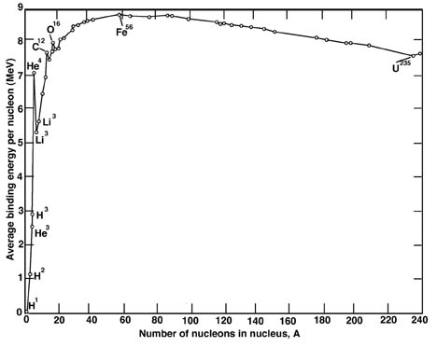

With reference to the graph, state whether or not the following statements are **True** **(T)** or **False (F)**.

(i) Binding energy per nucleon is a measure of the stability of a nucleus ________ (1 mark)

(ii) A carbon-12 nucleus is more stable than a tin-120 nucleus ________ (1 mark)

(iii) The fusion of 4 protons (H-1) into helium-4 releases about 28 MeV ________ (1 mark)

(iv) Fission of nuclei with mass number greater than 56 absorbs energy ________ (1 mark)

Question 20 (15 marks)

A common type of solar hot water system is the close-coupled thermosyphon shown in the diagram below. It consists of a flat plate collector containing an insulated black metal absorber plate, which typically has an area of about 4 m2. Water flows through copper tubes embedded in the surface of the absorber plate. Above the plate is a layer of air trapped beneath a flat glass cover. Solar energy is absorbed by the water in the tubes. The warm water enters the storage tank, which is located at the top of the system and usually has a capacity of about 300 L. Solar radiation in Perth has an average intensity of about 600 W/m2 on a clear spring day over 12 hours of sunlight.

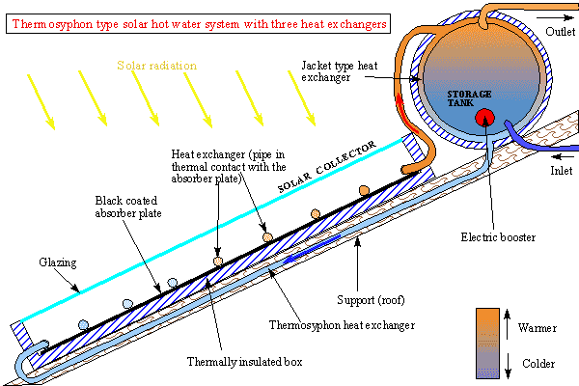

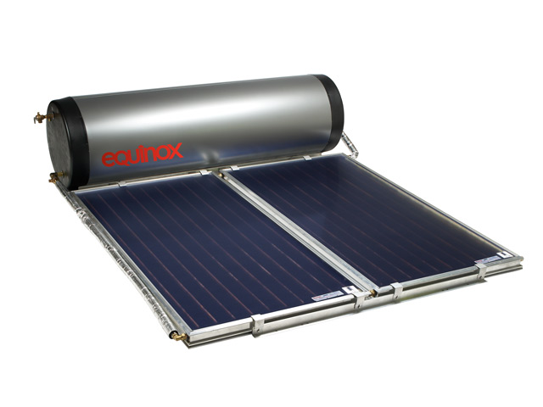

(a) Briefly explain how each of the following features of the collector plate allows for the maximum transfer of solar energy into thermal energy in the water:

(i) the collector plate contains a black coated metal absorber plate (2 marks)

(ii) the copper pipes are embedded in the surface of the absorber plate (2 marks)

(b) Explain how the glass cover over the collector plate helps minimise heat loss. (2 marks)

(c) In order to get maximum benefit from the system, the flat plate collectors are positioned on a north facing roof and angled so as to present maximum area to the winter sun. Why would the collector plate be angled so as to present maximum area to the winter sun? (2 marks)

(d) Why is a pump is not needed to move the water through the system? (2 marks)

(e) If the water in the tank is initially at 15°C, calculate the final temperature of the water in a typical system after 12 hours of heating on a clear spring day, given that the solar hot water system is 60% efficient. (5 marks)

**END OF SECTION TWO**

**Section Three: Comprehension (36 Marks)**

This section has **two (2)** questions. Write your answers in the spaces provided.

Suggested working time: 36 minutes.

**Question 21 OMHIC/NONOHMIC CIRCUIT COMPONENTS (16 marks)**

A Year 11 student carried out an experiment that measured the current through a particular circuit component, identified only as component X, as the voltage across it was successively increased. She then repeated the experiment for a second circuit component, identified only as component Y. The tables below show the data collected in the experiment by the student.

|  |  |  |  |
| --- | --- | --- | --- |
| **Component X** | | **Component Y** | |
| Voltage (V) | Current (A) | Voltage (V) | Current (A) |
| 2.12 | 0.14 | 2.05 | 0.24 |
| 3.95 | 0.27 | 3.86 | 0.41 |
| 5.78 | 0.39 | 5.68 | 0.53 |
| 7.69 | 0.53 | 7.43 | 0.63 |
| 9.56 | 0.64 | 9.25 | 0.71 |
| 11.45 | 0.75 | 11.20 | 0.79 |

(a) On the graph paper supplied on the next page, draw a graph of voltage versus current for each component, using the same set of axes. (5 marks)

(b) Which of the two components is an **ohmic** conductor? Calculate its resistance from your graph. (3 marks)

(c) What is the appropriate number of significant figures for your calculated value of resistance for the **ohmic** conductor? Briefly state why this is the appropriate number of significant figures. (2 marks)



(d) Could you use your calculated value of resistance to predict the current through the **ohmic** conductor if a voltage of 25.00 V was applied across it? Briefly explain. (2 marks)

(e) From the graph, find the resistance of the **nonohmic** conductor when the voltage across it is

(i) 6.0 V (1 mark)

(ii) 12.0 V (1 mark)

(f) Which of these estimated values of the resistance of the **nonohmic** conductor do you think is more reliable? Briefly explain your reasoning. (2 marks)

Question 22 NUCLEAR POWER (20 marks)

(Paragraph 1)

**Uranium-235** is one of the few materials that can undergo **nuclear fission**. If a free neutron collides with a U-235 nucleus, the nucleus can absorb the neutron, become unstable and split immediately into two lighter nuclei, throwing off two or three new neutrons (the number of ejected neutrons depends on how the U-235 nucleus happens to split). The two new nuclei then release beta and gamma radiation as they settle into their new states.

(Paragraph 2)

An incredible amount of energy is released, in the form of heat and radiation, when a single U-235 nucleus splits. The energy released comes from the fact that the fission products and the neutrons, together, weigh less than the original U-235 nucleus. The difference in mass is converted directly to energy at a rate governed by Einstein’s equation **E = mc2** and is of the order of 200 MeV (million electron volts) per fission.

(Paragraph 3)

To fuel a nuclear reactor, natural uranium must be **enriched** so that it contains 3 percent or more of U-235. The enriched uranium is formed into pellets, which are arranged into long rods, and the rods are collected together into bundles. The bundles are then typically submerged in water inside the reactor core. The uranium bundles act as an extremely high-energy source of heat. They heat the water and turn it into steam, which drives a **steam turbine**, and spins a **generator** to produce power.

(Paragraph 4)

The probability of a U-235 nucleus capturing a neutron depends on the speed of the neutron. A material called the **moderator** is present in the core of a nuclear reactor (usually water, or sometimes graphite) to slow down ejected neutrons and increase their probability of subsequent capture.

(Paragraph 5)

**Control rods** made of a material that absorbs neutrons, such as boron steel, are inserted into the reactor core using a mechanism that can raise or lower the control rods. Raising or lowering the control rods allows operators to control the rate of the nuclear reaction. When an operator wants the uranium core to produce more heat, the rods are raised out of the uranium bundle; to create less heat, the rods are lowered into the uranium bundle. In a reactor working properly (known as the **critical state**), one neutron ejected from each fission causes another fission to occur. The rods can also be lowered completely into the uranium bundle to shut the reactor down in the case of an accident or to change the fuel.

(Paragraph 6)

The reactor core is typically housed inside a concrete liner within a much larger steel containment vessel that is designed to prevent leakage of any radioactive gases or fluids. An outer concrete building that is strong enough to survive impact by crashing jet airliners protects the steel containment vessel. The absence of secondary containment structures in Russian nuclear power plants allowed radioactive material to escape at Chernobyl.

(Paragraph 7)

Uranium-235 is not the only possible fuel for a power plant. Another fissionable material is the artificial isotope **plutonium-239**. Pu-239 can be created easily from U-238 by bombarding it with neutrons - something that happens all the time in a nuclear reactor - in a 3-step process that involves the neutron bombardment of U-238 followed by successive beta decays that convert the uranium nucleus into a plutonium nucleus.

(a) One of the possible fission reactions for a U-235 nucleus is where it absorbs a neutron and splits into a barium-142 nucleus and a krypton-91 nucleus. Write the balanced nuclear equation for this fission reaction. (2 marks)

(b) One kilogram of uranium-235 contains approximately 2.5 x 1024 nuclei. Use information provided in paragraph 2 to estimate the

(i) energy released (in joules) if a kilogram of uranium-235 underwent fission. (3 marks)

(ii) difference in mass between the kilogram of uranium-235 undergoing fission and the fission products. (2 marks)

(c) In a typical nuclear power plant the fuel rods are submerged in water. Describe two functions the water may serve in the operation of the reactor. (4 marks)

(d) Briefly explain what is meant by each of the following terms.

**enrichment** (paragraph 3) (2 marks)

**critical state** (paragraph 5) (2 marks)

(e) State the purpose of the

**control rods** (2 marks)

**steel containment vessel**  (1 mark)

(f) Plutonium-239 can be produced from uranium-238 in a nuclear reactor, after the absorption of a neutron by the uranium-238, in a three step process. Show the two intermediate nuclides that are involved in this process. (2 marks)

U-238 → → → Pu-239

**END OF PAPER**

**EXTRA WORKING SPACE**

**EXTRA GRAPH PAPER**

